

[Artificial Intelligence in G](https://doi.org/10.1016/j.aiig.2022.12.003)e[osciences 3 (2022) 179–191](https://doi.org/10.1016/j.aiig.2022.12.003)

Contents lists available at ScienceDirect

Artificial Intelligence in Geosciences

journal homepage: [www.keaipublishing.com/en/journals/artificial-intelligence-in-geoscience](http://www.keaipublishing.com/en/journals/artificial-intelligence-in-geosciences)s

Estimation of the effectiveness of multi-criteria decision analysis and machine learning approaches for agricultural land capability in Gangarampur Subdivision, Eastern India

Sunil Saha, Prolay Mondal*

*Department of Geography, Raiganj University, Raiganj, West Bengal, 733134, India*

|  |  |
| --- | --- |
| A R T I C L E I N F O | A B S T R A C T |
| *Keywords:*  Analytic Hierarchy Process  Fuzzy Complex Proportional Assessment Receiver Operating Characteristic  Gangarampur subdivision  Soil Capability | Land suitability analysis (LSA) is an evaluation method that measures the degree to which land is suitable for certain land use. The primary aims of this study are to identify potentially viable agricultural land in the Gangarampur subdivision (West Bengal) using Multiple Criteria Decision Making (MCDM) and machine learning procedures and to evaluate the efficacy of the employed methodologies. The Analytic Hierarchy Process (AHP) model was used to assign relative weights to the fifteen various criteria in this suitability analysis, and then the Fuzzy Complex Proportional Assessment (FCOPRAS) model was applied using the AHP’s normalised pairwise comparison matrix, whereas the Waikato Environment for Knowledge Analysis (Weka) Software was used to apply machine learning algorithms to the field data. The Random Forest (RF) model, on the other hand, is a better fit for the locational study of soil potential. According to the RF findings, areas of 14.67 per cent (15368.46 ha) are excellent (ZONE V) for growing crops, approximately 22.30 per cent (23367.9 ha) are highly suitable (ZONE IV), and 23.63 per cent (24762.12 ha) are moderately suitable (ZONE III) for cultivation, respectively. The numbers for FCOPRAS are roughly 15.39% (16130.52 ha), 22.54% (23620.65 ha), and 19.79% (20733.26 ha). The Receiver Operating Characteristic (ROC) curve and accuracy measurements of the results indicate the high accuracy of the applied models, with Random Forest and FCOPRAS being the most popular and effective techniques. This study will make an important contribution to evaluations of soil fertility and site suitability. This will help local government officials, academics, and farmers scientifically use the land. |

**1. Introduction**

Agriculture is the world’s most primitive economic activity (Prakash, 2003), occupying one-third of the world’s entire land surface (Grigg, 1995). Following industrialization (Davis and Langham, 1995), the world’s population increased positively and food demand increased rapidly (Lambin and Meyfroidt, 2011; Scherer et al., 2018; Alexandratos and Bruinsma, 2012), resulting in the intensification and extensification (Yalew et al., 2016; Tscharntke et al., 2012) of the primary sector to sustain the supply and demand chain (Naik and Suresh, 2018). To sus-tain an increasing human population, the only approach is to boost agricultural output (Ibrahim et al., 2016) without endangering future generations’ requirements (Feizizadeh et al., 2014; Turgut et al., 2013). The Dakshin Dinajpur district’s economy is primarily based on the pri-mary economic sector, more precisely on agriculture. According to census (2011) data, a total of 170,682 cultivators engage in agriculture

cultivation, with 156,797 males and 13,885 women; and 174,690 in-dividuals working as labourers on agricultural land, with 129,402 men and 45,288 women. Paddy, wheat, barley, and maize are the most widely farmed food grains. Agriculture’s development is critical to the socio-economic development of the study area. Agriculture develop-ment has a huge impact on people’s socioeconomic conditions, and it is critical to building optimal agriculture practices to enable people to self-sustain (Pramanik, 2016). Population pressure on agricultural land and strong demand (Cowie et al., 2018) for foods necessitate speedy production or high-yield agriculture. Due to the excessive use of chemical fertilizers and pesticides, insufficient irrigation infrastructure, insufficient transportation systems, depleted soil fertility, soil erosion, and other factors, agricultural production has fallen quickly (De la Rosa and Sobral, 2008).

Land suitability analysis (LSA) is a method of figuring out how well land can be used for a certain purpose (Mistri and Sengupta., 2020). The

* Corresponding author.

*E-mail addresses:* [sahasunil2507@gmail.com](mailto:sahasunil2507@gmail.com) (S. Saha), [mon.prolay@gmail.com](mailto:mon.prolay@gmail.com) (P. Mondal).

<https://doi.org/10.1016/j.aiig.2022.12.003>   
[Received 12 September 2022; Received in r](https://doi.org/10.1016/j.aiig.2022.12.003)evised form 21 December 2022; Accepted 22 December 2022   
Available online 29 December 2022   
2666-54[41/© 2022 The Authors. Publishing services](http://creativecommons.org/licenses/by/4.0/) by Elsevier B.V. on behalf of KeAi Communications Co. Ltd. This is an open access article under the CC BY license (<http://creativecommons.org/licenses/by/4.0/>).

*S. Saha and P. Mondal*  *Artificial Intelligence in Geosciences 3 (2022) 179–191*

land/soil suitability evaluation is required to decide which crop is most suited to a place with limited resources (Jamil et al., 2018). Land is a unique and significant element on the earth’s surface (Rossiter, 1996), and every living entity interacts with it directly or indirectly. Potential Suitability Assessment of Land (PSAL) determines the land’s suitability for a specified use (Bandyopadhyay et al., 2009; Hayashi, 2000). The basic purpose of “PSAL” is to ascertain people’s satisfaction with a particular land use form (Hopkins, 1977), and it can assist policymakers in developing strategies to increase agricultural productivity by identi-fying potentially suitable land for cultivation (FAO, 1976; Malczewski, 2004). MCDM approaches are commonly used to estimate the potential and inherent properties of soil (Mendas and Delali, 2012) and to determine the optimal Zones for cultivation (Steiner et al., 2000). Mosadeghi et al. (2015) say that MCDM uses a lot of variables to predict how land will be used in the future.

The integration of remote sensing, GIS, and MCDM methodologies will always be promising for identifying new suitable places (Halder et al., 2020). Mokarram and Aminzadeh (2010) suggest that Geographic Information System (GIS) is a more adaptable system for acquiring, investigating, and evaluating data and outcomes. Researchers can fix small mistakes more quickly and get more accurate results by working together (Saaty, 1980; Duc, 2006).

There has been a significant amount of research on site suitability studies utilising MCDM and ML techniques, including Site Suitability Assessment for Rice Cultivation (Nyeko, 2012; Kihoro et al., 2013), Site suitability for agriculture (Zaredar and Jafari, 2010), for land manage-ment purposes (Rojas and Loubier, 2017) for land-use suitability (Joerin et al., 2001; Romeijn et al., 2016) for Land suitability analysis for various crops (Jamil et al., 2018), for avulsion potential Zone con-struction (Pal and Sarkar, 2018), for the recognition of touristic poten-tial Zones (Ebrahimi et al., 2019), site suitability for conservation of water (Srdjevic and Medeiros, 2007) and water management (Badhe et al., 2019), Predicting the Soil Suitability (Jayaraman et al., 2021); Prediction of Cardiac Disease (Princy et al., 2020); Mapping the risk terrain for crime (Wheeler and Steenbeek, 2021) and executing surface and pressurized irrigation system (Azad et al., 2019), etc.

In this study, the FCOPRAS (Fuzzy Complex Proportional Assess-ment), AHP, and machine learning approaches, namely Random Forest and Multilayer Perceptron have been used to discover the potentiality of the soil for agriculture, and ROC and Accuracy techniques have been also applied to estimate the proficiency of the applied models and al-gorithms. Before arriving at the outcome, the weight of the alternatives for each variable was calculated (Malczewski and Boroushaki, 2008; Murayam and Bunruamkaew, 2011) using AHP. The opinions of three experts were considered in the whole process of the FCOPRAS. To aggregate the performing variables, the WLCM (Weighted Linear Com-bination Method) was used.

The land suitability assessment approach is a method for analysing land’s potential to determine the best location for growing various crops. In planning and managing land resources, one of the most ad-vantageous uses of the Geographic Information System (GIS) is the study of site suitability and preparation of land use maps. GIS and Multi- Criteria Decision Analysis (MCDA) can be used well enough for plan-ning and managing how agricultural land is used (Adeniyi, 1993; Shearer and Xiang, 2009). GIS makes it easy to store, process, and analyse complex raw data at plenty of different levels. Combining MCDM and Machine Learning (ML) with Geographic Information Sys-tems (GIS) is an excellent technique (S´anchez-Lozano et al., 2013) to make good judgments in complex and dynamic agricultural systems.

Agriculture is the economic backbone of West Bengal, employing about 60–70 per cent of the workforce and generating nearly 19.9 per cent of the state’s GDP in 2020–21. In terms of food grain production, the state has achieved self-sufficiency. Only 48% of the Dakshin Dinaj-pur district’s (West Bengal, India) geographic area is inside the research area. Because this district lacks an industrial sector, its economy is pri-marily agrarian. The overall quantity of land in the Gangrampur

180

*S. Saha and P. Mondal*  *Artificial Intelligence in Geosciences 3 (2022) 179–191*

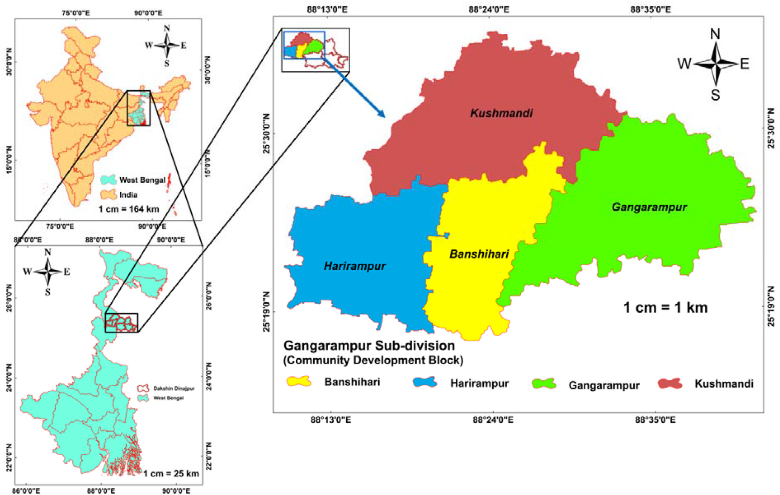

**Fig. 1.** Geographical location of the study area.

**Table 1**   
Performing Variables, Sources, and their resolution.

|  |  |  |  |
| --- | --- | --- | --- |
| Name of the Variable | Source | Website | Resolution (m) |
| Nitrogen (*N*)  Phosphate   (*PO*3−4)  Potassium (*K*) Zinc (*Zn*)  Sulphur (*S*)  Copper (*Cu*)  Boron (*B*)  Manganese   (*Mn*)  Soil Depth (*Sd*) Electrical   Conductivity (*EC*)  Cation   Exchange   Capacity   (*CEC*)  Potential of   Hydrogen   (pH)  Bulk Density   (*BD*)  Moisture Index (*MI*) | Primary Data were  collected from 40 spots from the Study Area  (Laboratory Test) | Field Survey | 30 × 30 |
| 30 × 30 30 × 30 30 × 30 30 × 30 30 × 30 30 × 30 |
| Secondary Data For MI, the NDWI was  calculated | [https://soilgrids.org](https://soilgrids.org/) [/](https://soilgrids.org/) | 30 × 30  30 × 30  (resample |
| Landsat 8 OLI | 30 × 30 |
| *NDWI* = |
| Soil Texture (*STEX*) | (*Band*3 − *Band*5) (*Band*3 + *Band*5) | 30 × 30 |

*3.1.1. The rationale for selecting the variables*

*3.1.1.1. Nitrogen (N) and copper (Cu).* Nitrogen is crucial for plant growth (structure), plant food processing (metabolism), and chlorophyll

181

*S. Saha and P. Mondal*  *Artificial Intelligence in Geosciences 3 (2022) 179–191*

the EC (Dedeo˘glu and Dengiz, 2019), and crop yields, crop suitability, plant nutrient availability, and the activity of soil microbes, etc are all controlled by EC (Do Carmo et al., 2016). CEC is the total amount of exchangeable cations that a soil, soil component, or other material can hold at a certain pH (van Erp et al., 2001). Cation exchange capacity (CEC) is a helpful indication of soil fertility because it indicates the ca-pacity of the soil to deliver three essential plant nutrients: calcium, magnesium, and potassium (Ross and Ketterings, 1995). Similar to the study area, a high concentration of salts (Higher value of EC) in the soil impacts the Kharif crop (Sown in Rainy Season) production negatively and essential variable for Rabi crops (Sown in Winter) cultivation (Francois et al., 1986).

*3.1.1.6. Soil organic carbon (SOC) and soil pH.* Soil organic carbon (SOC) accumulation is influenced in agricultural areas where the bare soil occurs frequently for several months, especially during hot summers and inconsistent rainfall seasons (Schillaci et al., 2019) and this varia-tion in SOC controls the Copper content in the soil. Otherwise, they’ll fail just as badly as if they were missing key components. Soil pH is thereby referred to as the “master soil variable” since it controls a myriad of soil biological, chemical, and physical qualities as well as processes that affect plant growth and biomass yield (Neina, 2019). The pH of the soil is a proxy for the activity or concentration of hydrogen ions ([H+]) in the soil solution. As H+ activity increases, the pH of the soil lowers. As soil pH drops, the most desirable crop nutrients become less available, while others, which are frequently undesirable, become more available and can reach toxic levels.

*3.1.1.7. Bulk density and soil moisture.* The availability of water, root growth, and the flow of air and water through the soil are all impacted by high bulk density. Soil bulk density is a basic though essential physical soil parameter related to soil porosity, soil moisture, and hy-draulic conductivity, which is essential for soil quality evaluation and land use management (Li et al., 2019). Crop health is dependent on a sufficient supply of rainfall and soil nutrients, among other things. Plants’ natural functions and growth are interrupted as moisture avail-ability decreases, resulting in lower crop yields. The NDWI was calcu-lated to determine the soil moisture of the study area (Pramanik, 2016) as it is a good indicator of soil moisture. To calculate NDWI the Landsat-8 imageries were collected from the USGS data portal with 30 m resolution (<https://earthexplorer.usgs.gov/>).

*3.1.1.8. Soil depth and soil texture.* The depth of the soil influences the types of plants that can survive there. Deeper soils often supply more water and nutrients to plants than shallower soils (Abd-Elmabod et al., 2017). The texture of the soil is the size distribution of grains composed of minerals. The soil texture is determined by three types of grains e.g. sand (2–0.05 mm), silt (0.05–0.002 mm), and clay (below 0.002 mm). Soil texture is an important factor in choosing which crops to cultivate because it affects how porous the soil is, how well it holds water, and how dense it is (Chakraborty and Mistri, 2015). In this research, the soil texture data has been collected from the ‘Soil series of West Bengal (Vol. 89), National Bureau of Soil Survey and Land Use Planning, Indian Council of Agricultural Research which is the work of Nayak, D.C. (2001).

*3.2. Methods*

In the current study, MCDM methodologies such as AHP (Analytical Hierarchy Process), Fuzzy Complex Proportional Assessment (FCOP-RAS) methods, as well as machine learning approaches such as Random Forest (RF) and Multilayer Perceptron (MLP) in the present study. When Weighted Linear Combination (WLCM) and MCDM (AHP, FCOPRAS) are used together, the best result is always reached.

182

*S. Saha and P. Mondal*  *Artificial Intelligence in Geosciences 3 (2022) 179–191*

*Vrating* =⎡⎢⎢⎣*D*1

*D*2

*D*3 *m*= *l*  *m*= *l*  *m*= *l*   
 *m*

*m*

*m*   
 *u*

*u*

*u* ⎤ ⎥⎥⎦  
 (7)

Where, *Vrating* is the rating assigned by several decision-makers of a particular variable; ’*l*′′*m*′′*u*’ is the lower, middle, and upper weight of the variable; ‘*Dm*’ is the decision-maker (Table 3; Table 4).

After formulation of the tabulation of the weights of the variables assigned by the decision-makers, the Fuzzy-aggregation technique has been employed (Turanoglu Bekar et al., 2016) (Eq. (8)).

*FA* = (*l* + *l* + *l* ) ; (*m* + *m* + *m* ) ; (*u* + *u* + *u* ) (8)

Where, *FA* is the Fuzzy Aggregation of the fuzzy weights; *n* is the number of decision-makers.

After the fuzzy aggregation, the AHP normalised matrix values have been used to form a fuzzy weighted normalised decision matrix (Eq. (9)).

*xw m*=

To normalise the primary pair-wise matrix Eq. (4) was applied to it. [ *AHPn*−*matrix*⊗ *FA l,m,u*] (9)

Using Eqs. (10) and (11), the values of the benefit and cost variables were estimated.

*k*

*FBi* =∑*Nij*  (10)

*m*

*FCi* = *j*=*k*+1∑*Nij*  (11)

Where ‘*FBi*’ is the Fuzzy benefit variable and ‘*FCi*’ is the Fuzzy cost variable.

After the classification of variables into benefit and cost variables, the relative significance (*Ri*) of each alternative has been estimated using Eq. (12).

|  |  |  |
| --- | --- | --- |
| *n*  *Ri* = *FBi* + min(*FCi*) ×∑ *FCi* ×∑( min(*FCi*) *FCi*  *FCi*  ) (12)  Where, ‘*Ri*’ is the relative significance.  Furthermore, the utility degree of each alternative (Table 5) has been calculated using Eq. (13). | | |
| *Ud i*= | *Ri*  max(*Ri*) × 100 | (13) |

Where, ‘*Ud i*’ is utility degree.

In this study, the normalised matrix from AHP (Table 5) was used in the FCOPRAS model to estimate the weight of the variables. The CO-PRAS in conjunction with the fuzzy set produces more accurate and refined outputs because fuzzy sets utilize good algorithms to direct incompetence, uncertainty, and dubiety (Zhang and Achari, 2010; Elaalem, 2012), and it improves output acceptance.

**Table 3**   
Relative importance scale for FCOPRAS.

|  |  |  |  |  |
| --- | --- | --- | --- | --- |
| Importance | Linguistic form | Rating |  |  |
| Extremely low Very low  Low  Medium  High  Very High  Extremely high | EL  VL  L  M  H  VH  EH | 0  0  0.1  0.3  0.5  0.7  0.9 | 0  0.1  0.3  0.5  0.7  0.9  1 | 0.1  0.3  0.5  0.7  0.9  1  1 |

183

|  |  |  |  |  |  |  |
| --- | --- | --- | --- | --- | --- | --- |
| *S. Saha and P. Mondal* | | **CI:**0.03  **CR:**0.02  Model’s result Acceptable | 4 : Phosphate; *K*: Potassium; *Zn*: Zinc; *S*: Sulphur; *Sd*: Soil Depth; *Cu*: Copper; *B*: Boron; *Mn*: Manganese; *EC*: Electrical Conductivity; *CEC*: Cation Exchange Capacity; *PH*: Potential Hydrogen; *BD*: Where, *N*: Nitrogen; *PO*3−  Bulk Density; *MI*: Moisture Index; *STEX*: Soil Texture. | *Artificial Intelligence in Geosciences 3 (2022) 179–191* | | |
| Consistency Checking | | number of variables to sample at random as candidates in each split is 1 (Liaw and Wiener, 2002), min*sampsize* i.e the set of samples used to train (min) is 3, max number of levels in each decision tree 80, ‘maxnodes’ i.e the terminal nodes (max) and ‘nodsize’ i.e the terminal nodes (min) is remain default. | | |
| *3.2.2.2. Multilayer perceptron algorithms.* One of the most basic feed- forward neural networks is the Multilayer Perceptron. Multilayer per-ceptrons are bidirectional neural networks in which the inputs are propagated forward and the weights are propagated backward (Brei-man, 2001). A multilayer perceptron has an input layer and an output layer with one or more hidden layers. All MLPs connect all neurons in one layer to all neurons in the next layer. The input layer receives the input signals, and the output layer performs the intended task. All of the calculations are done by the hidden layers (Wang et al., 2021). | | |
| *i* ) FCOPRAS Weight (*Ud* | | 1.00  0.88  0.88  0.80  0.94  0.88  0.84  0.88  0.84  0.68  0.96  0.59  0.74  0.69  0.99 |
| *3.2.3. Effectiveness estimation of applied models/algorithms* | | |
| AHP Weight (*vw*) | |
| 0.09  0.08  0.08  0.07  0.08  0.08  0.07  0.08  0.07  0.04  0.07  0.05  0.03  0.04  0.07 | *3.2.3.1. 3.2.3.1. ROC (receiver operating characteristic curve).* The Receiver Operating Characteristic Curve (ROC curve) is a graph that shows the output of a classification model at all classification levels. If the area under the ROC curve (AUC) values between 0.9 and 1 were considered excellent, the values between 0.8 and 0.9 were considered good, the values between 0.7 and 0.8 were considered fair, the values between 0.6 and 0.7 were considered poor, and the values between 0.5 and 0.6 were considered failed (Bradley, 1997; Sarkar et al., 2022). | | |
| *STEX* | | 0.07  0.07  0.07  0.07  0.07  0.07  0.07  0.07  0.07  0.07  0.07  0.07  0.07  0.03  0.07 |
| *MI* | | 0.07  0.07  0.07  0.07  0.07  0.07  0.07  0.07  0.07  0.04  0.07  0.07  0.07  0.04  0.07 |
| *BD* | | 0.08  0.08  0.08  0.08  0.08  0.08  0.08  0.08  0.08  0.05  0.05  0.08  0.03  0.01  0.03 | *3.2.3.2. Accuracy measurement.* Accuracy is defined as the degree to which the outcome of measurement corresponds to the correct value or a standard and refers to the degree to which a measurement is near to its agreed-upon value, i.e., it is the degree of consistency between the outcome of measurement and the true value of the thing being measured. Equation 16 was used to measure the accuracy of the final outputs. The flow diagram and soil testing processes of the whole study area are in Fig. 2. | | |
| *PH* | | 0.09  0.09  0.09  0.09  0.09  0.09  0.09  0.09  0.09  0.02  0.04  0.04  0.01  0.02  0.04 |
| **Table 5**  Normalised pair-wise comparison matrix with criteria rating, CI and CR, AHP and FCOPRAS Weights. | *CEC EC Mn B Cu Sd S Zn K* 4 *PO*3−*N* Variable | 0.07  0.07  0.07  0.07  0.07  0.07  0.07  0.07  0.07  0.07  0.07  0.07  0.04  0.04  0.07 |
| 0.08  0.08  0.08  0.08  0.08  0.08  0.08  0.08  0.08  0.04  0.04  0.08  0.02  0.04  0.04 | *Accuracyoverall*= ( (∑*predicted values*) (∑*true values*) )  **4. Result analysis** | × 100 | (15) |
| 0.14  0.07  0.07  0.07  0.07  0.07  0.07  0.07  0.07  0.04  0.07  0.04  0.02  0.04  0.07 |
| 0.08  0.08  0.08  0.08  0.08  0.08  0.08  0.08  0.08  0.04  0.08  0.04  0.03  0.04  0.08 | *4.1. Execution of the AHP method for estimating relative weights of the variables* | | |
| 0.14  0.07  0.07  0.07  0.07  0.07  0.07  0.07  0.07  0.04  0.07  0.04  0.02  0.04  0.07 | All the selected sixteen different variables including nitrogen (N), copper (Cu), manganese (Mn), zinc (Zn), sulphur (S), boron (B), phos-phate, and potassium (K), electrical conductivity (EC), Cation Exchange Capacity (CEC), soil pH, bulk density, soil moisture, soil organic carbon, soil depth, and soil texture have been classified into suitable classes based on natural break classification in GIS environment. The Inverse Distance Weighted (IDW) interpolation (Chen and Liu, 2012) technique has been used to generate spatial distribution maps.  The spatial distribution of nitrogen (N) has been categorised (Fig. 3a) into five potential classes based on natural break classification (Febrianto et al., 2016) in the GIS environment, where the *>*70 Zone has the most potential, with 20.83 per cent (21832.44 ha) area. The 1.64–1.98 copper (Cu) Zone (Fig. 3b) is more suitable, with an 11.79 per cent (12354.32 ha) area. The thematic distribution of manganese (Mn) and zinc (Zn) is (Fig. 3c; Fig. 3d) also classified into five classes, where the 16.37–19.98 Mn Zone and the 0.87–0.99 Zn Zone have more po-tential, with 15.23 per cent (15955.27 ha) and 5.95 per cent (6234.64 ha) of the total area, respectively. The spatial database of the Sulphur (Fig. 3e) has been classified as 67.36–71.85, 71.85–79.76, 79.76–87.00, 87.00–96.01, and 96.01–113.36, respectively. Boron Zone 0.32–0.36 (Fig. 3f) has the most potential, with a 13.31 per cent (13951.9 ha) area. The Phosphate (Fig. 3g) Zone 255.74–310.30 has the most potential, | | |
| 0.08  0.08  0.08  0.08  0.08  0.08  0.08  0.08  0.08  0.04  0.08  0.04  0.03  0.04  0.08 |
| 0.08  0.08  0.08  0.04  0.08  0.08  0.08  0.08  0.08  0.04  0.08  0.04  0.03  0.04  0.08 |
| 0.13  0.07  0.07  0.07  0.13  0.07  0.07  0.07  0.07  0.03  0.07  0.03  0.02  0.03  0.07 |
| 0.08  0.08  0.08  0.08  0.08  0.08  0.08  0.08  0.08  0.04  0.08  0.04  0.03  0.04  0.08 |
| 0.08  0.08  0.08  0.08  0.08  0.08  0.08  0.08  0.08  0.04  0.08  0.04  0.03  0.04  0.08 |
| 0.09  0.09  0.09  0.04  0.09  0.09  0.04  0.09  0.04  0.04  0.09  0.04  0.03  0.04  0.09 |
| *N*  4 *PO*3− *K*  *Zn*  *S*  *Sd*  *Cu*  *B*  *Mn*  *EC*  *CEC*  *PH*  *BD*  *MI*  *STEX* |

184

*S. Saha and P. Mondal*  *Artificial Intelligence in Geosciences 3 (2022) 179–191*

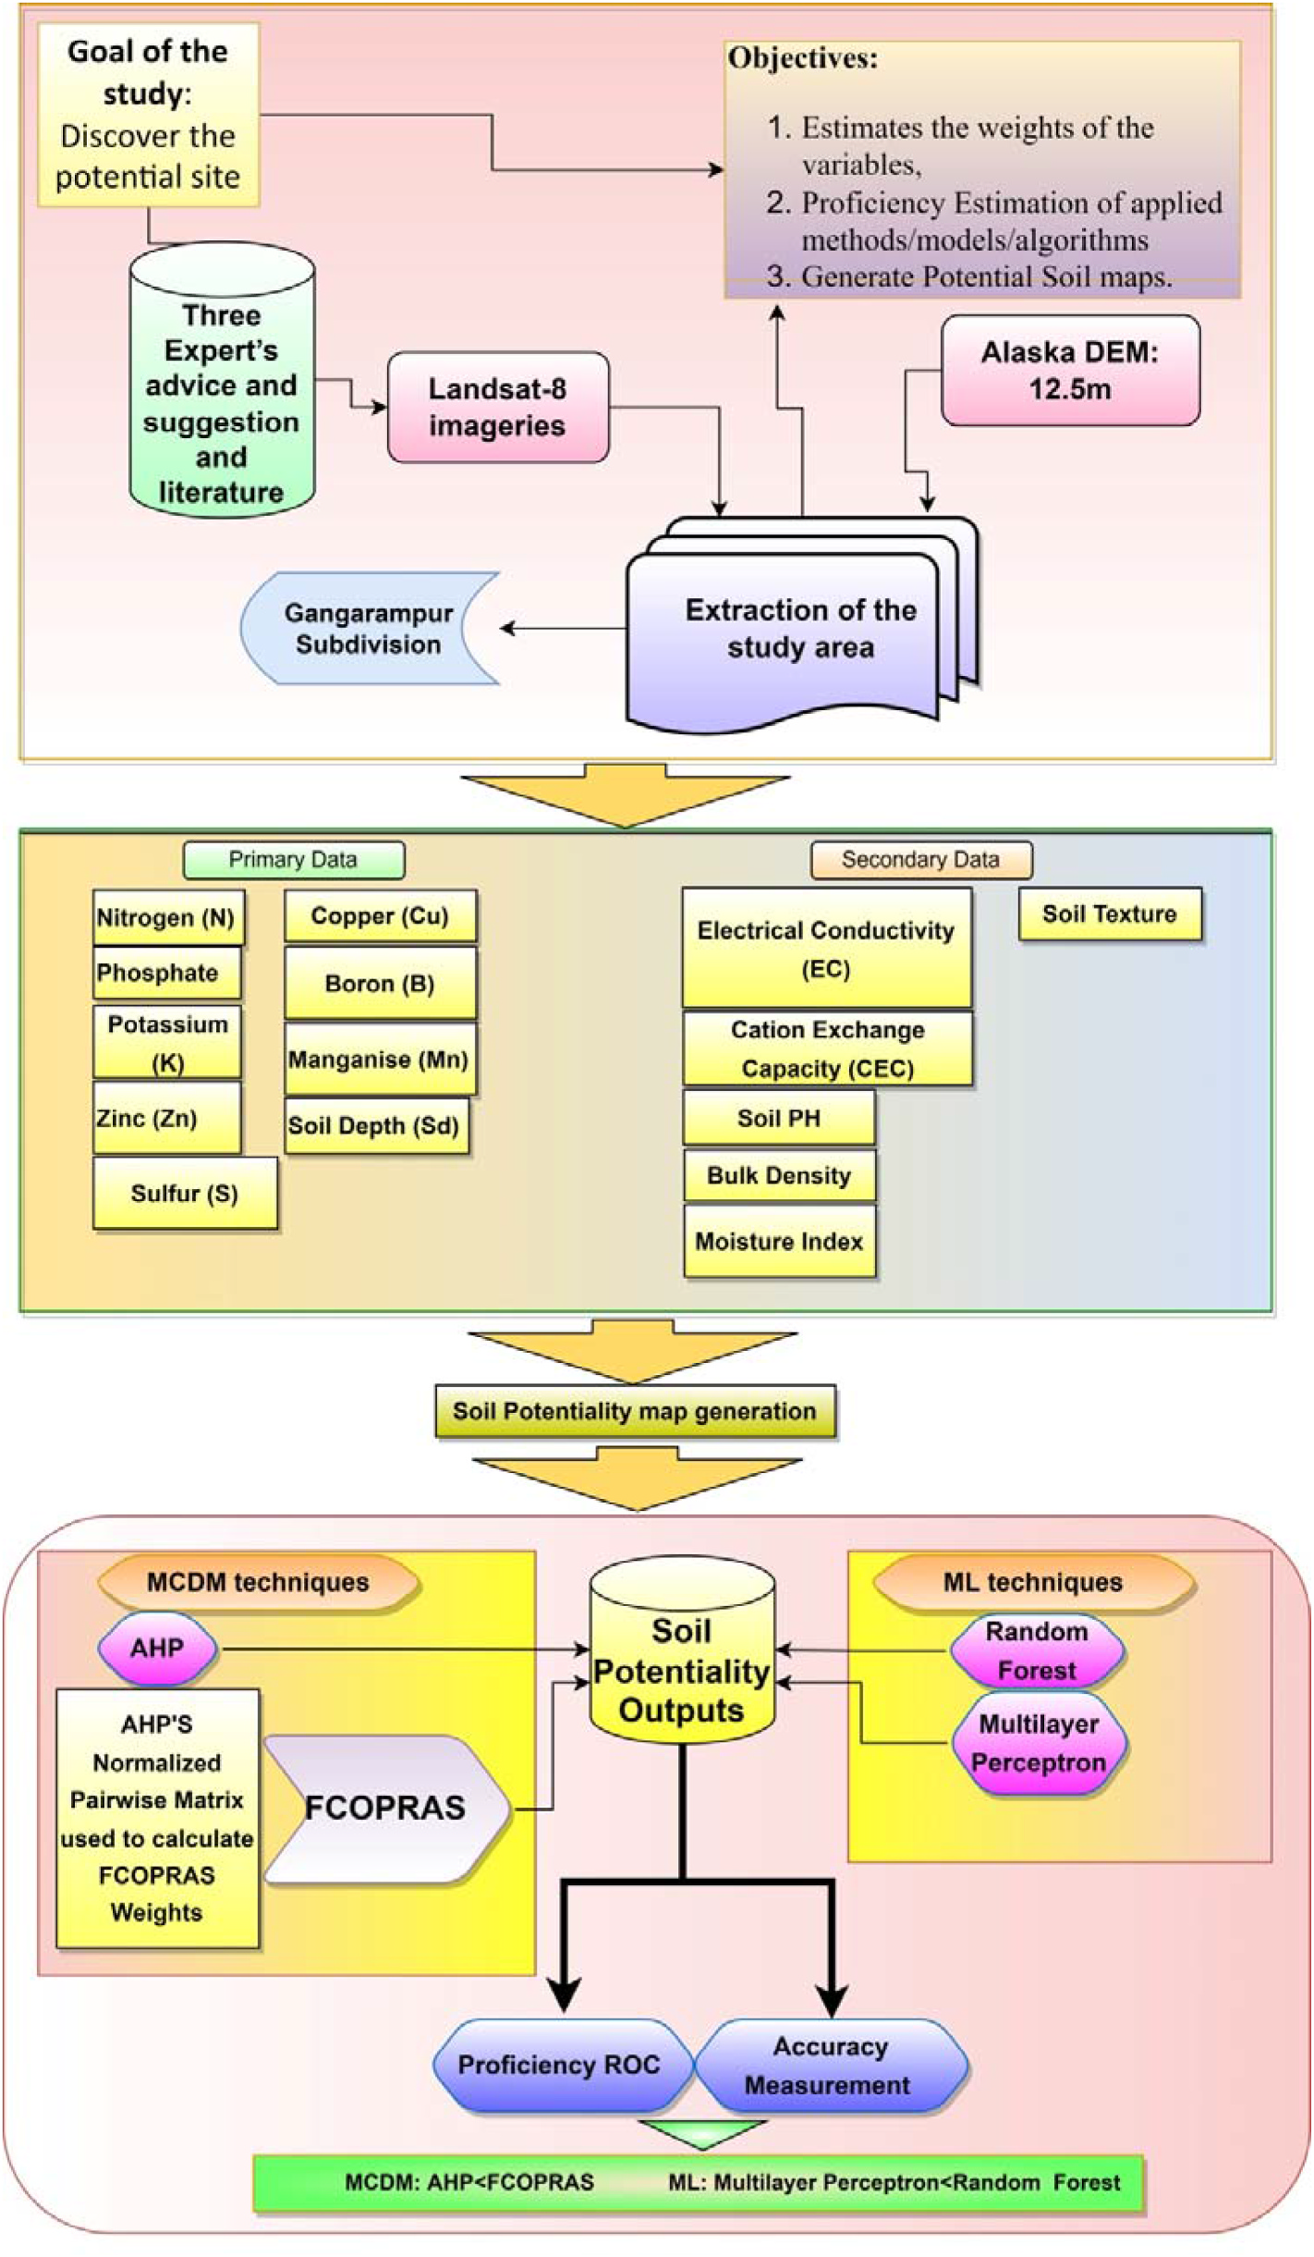

**Fig. 2.** Flow diagram of the Whole Study.

accounting for 7.01 per cent (7346.602 ha) of the total area. The spatial layer of the potassium (K) has (Fig. 3h) been classified into five potential classes, where the *>*70 Zone is the most suitable, with a 20.83 per cent (21832.44 ha) area. The Electrical Conductivity (Fig. 3i) Zone 1.41–2.29 and the Cation Exchange Capacity (CEC) Zone (Fig. 3g) 21.74–26.96 have a potential of 20.37 per cent (21350.92 ha) and 9.45 per cent

185

*S. Saha and P. Mondal*  *Artificial Intelligence in Geosciences 3 (2022) 179–191*

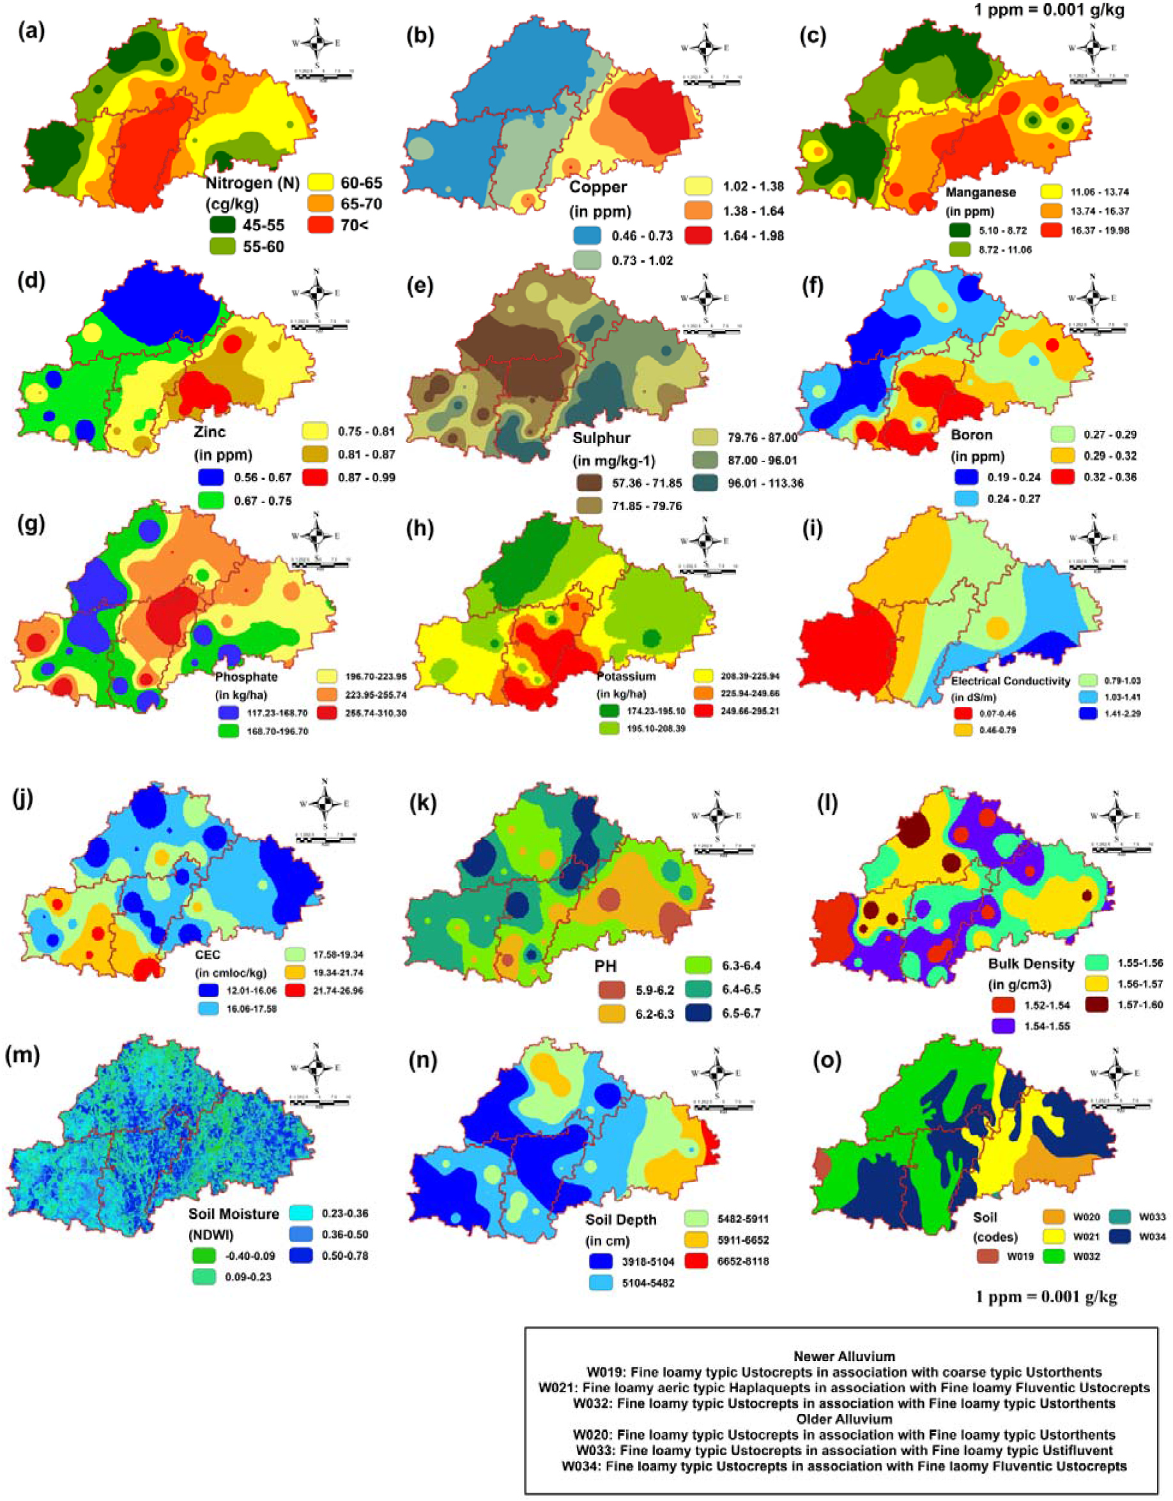

**Fig. 3.** Influecing variable of the Soil Fertility (a–o); (a) Nitrogen (N), (b) Copper, (c) Manganese, (d) Zinc, (e) Sulphur, (f) Boron, (g) Phosphate, (h) Potassium, (i)

Electric Conductivity(EC), (j) CEC, (k) PH, (l) Bulk Density, (m) Soil Moisture, (n) Soil Depth, (o) Soil texture.

thematic layer of soil (Fig. 3o) has been classified into six classes: W019, W020, W021, W032, W033, and W034 respectively. W019, W021, and W032 belong to the new alluvial Zone, which has a high potential for cultivation with 38.18 per cent (40009.26 ha), 39.28 per cent (41156.81 ha), and 13.83 per cent (14490.93 ha) respectively.

186

*S. Saha and P. Mondal*  *Artificial Intelligence in Geosciences 3 (2022) 179–191*

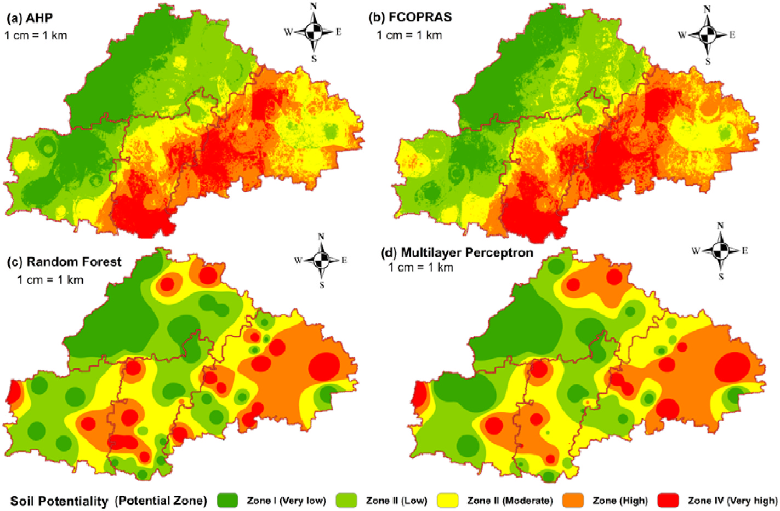

**Fig. 4.** Potential soil mapping (a–d); (a) AHP, (b) FCOPRAS, (c)Random forest, (d) multilayer perceptron.

(High) accounts for 20.52 per cent (21503.99 ha), and Zone V (Very High) accounts for 12.53 per cent (13133.67 ha).

The final potential suitability map using FCOPRAS weight has been generated in the GIS environment and classified (Fig. 4b) into five suitable Zones: Zone I (Very Low) with 17.51 per cent (18344.56 ha), Zone II (Low) with 24.77 per cent (25961.01 ha), Zone III (moderate) with 19.79 per cent (20733.26 ha), Zone IV (High) with 22.54 per cent (23620.65 ha), and Zone V (Very high) with 15.39 per cent (16130.52 ha) of the total area, respectively (Table 6).

**Table 6**   
Area distribution of potential classes using MCDM and ML.

AHP

|  |  |  |  |
| --- | --- | --- | --- |
| Zone | Potentiality | Area (%) | Area (ha) |
| ZONE I  ZONE II  ZONE III  ZONE IV  ZONE V | Very Low  Low  Moderate  High  Very High | 22.50  24.87  19.57  20.52  12.53 | 23581.74 26062.27 20508.32 21503.99 13133.67 |

FCOPRAS

|  |  |  |  |
| --- | --- | --- | --- |
| Zone | Potentiality | Area (%) | Area (ha) |
| ZONE I  ZONE II  ZONE III  ZONE IV  ZONE V | Very Low  Low  Moderate  High  Very High | 17.51  24.77  19.79  22.54  15.39 | 18344.56 25961.01 20733.26 23620.65 16130.52 |

Random Forest

|  |  |  |  |
| --- | --- | --- | --- |
| Zone | Potentiality | Area (%) | Area (ha) |
| ZONE I  ZONE II  ZONE III  ZONE IV  ZONE V | Very Low  Low  Moderate  High  Very High | 18.46  20.94  23.63  22.30  14.67 | 19343.35 21948.15 24762.12 23367.9  15368.46 |

Multilayer Perceptron

|  |  |  |  |
| --- | --- | --- | --- |
| Zone | Potentiality | Area (%) | Area (ha) |
| ZONE I  ZONE II  ZONE III  ZONE IV  ZONE V | Very Low  Low  Moderate  High  Very High | 10.53  26.02  35.99  22.01  5.46 | 11031.33 27262.28 37718.49 23059.92 5717.977 |

187

*S. Saha and P. Mondal*  *Artificial Intelligence in Geosciences 3 (2022) 179–191*

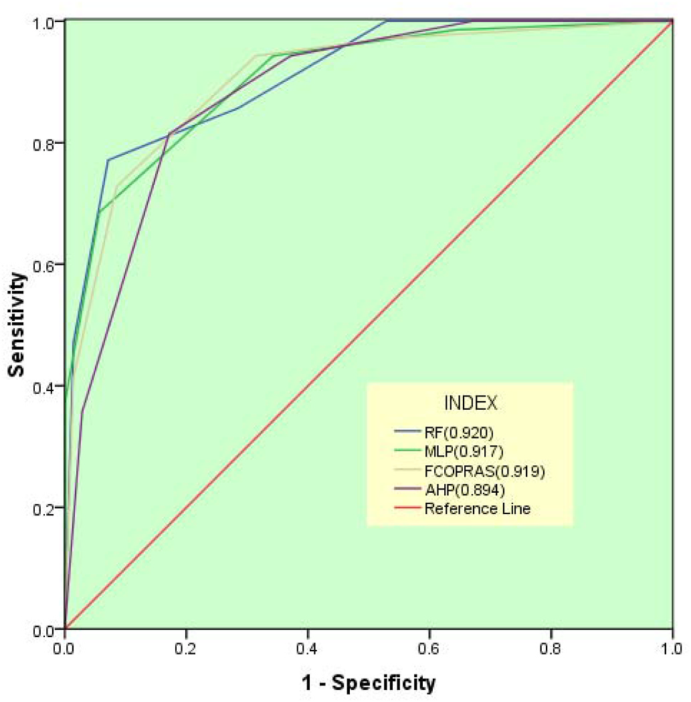

**Fig. 5.** Validation of the results applying ROC.

**6. Discussion**

*6.1. Soil potentiality*

Based on the results of the MCDM, Berail, Deul, Akcha G.P. (Khus-mandi C.D. Block), Gokamo, and Bagichapur G.P. (Harirampur C.D. Block) have very low soil potential, while Udaypur, Kalikamera, and Maligaon G.P. have higher soil potential. Places with very high soil potential for agriculture include Ellahbad (Banshihari C.D. Block), Bel-bari, Gangarampur G.P. (Gangarampur C.D. Block), etc. From the ML outputs, it is found that Sukhdebpur G.P., Maligaon G.P., Basuria G.P. Nandanpur G.P., NW Saiyadpur G.P., Southern Sirshi G.P., Ganguria G. P., NW Karanji G.P. have the least potential, whereas Berail G.P., Deul G. P., Akcha G.P., Asokegram G.P., Kushmandi G.P., Northern Karanji G.P., etc have the highest potential for agriculture.

Deficiency in Nitrogen, Copper (Chaudhry and Loneragan., 1970), low Soil Moisture (Nagy et al., 2007), Deficiency in Manganese (Schmidt et al., 2016), Zinc, Sulphur, Boron, Phosphate, Potassium (Seth et al., 2018), High Bulk Density (Blake, 1965), Older Alluvial Soil, High pH, and least soil depth, etc are the main reason behind low to very low potentiality of Soil for agriculture. Whereas Optimum concentration of Nitrogen (*>*65 cg/kg−1), Copper (1.02–1.98 ppm), Soil Moisture (0.36–0.78), Manganese (11.0–19.98 ppm), Zinc (0.75–0.99 ppm), Boron (0.25–0.38 ppm), Sulphur (75.0–113.36 mg/kg−1), Phosphate (*>*195.0 kg/ha−1), Potassium (*>*200 kg/ha−1), low Bulk Density (*<*1.55 g/cm3), Older Alluvial Soil, ideal PH (6.5–7.5), low EC (*<*0.46 dS/m−1), higher CEC activity (*>*20.0 cmloc/kg−1) and ideal soil depth (*<*5000 cm) etc are the main reason behind low to very low soil positive po-tentiality for agriculture. **(1 ppm ¼ 0.001 g/kg**).

*6.2. Model calibration, validation, and effectiveness*

From the areal changing matrix, it is found that there is about +4.998 per cent variation for Zone I from the FCOPRAS to AHP, whereas it is −0.215 per cent for Zone III and −2.860 per cent for Zone V. The ROC and accuracy estimation indicate that the FCOPRAS is more valid and accurate than the AHP, with 91.9 percent and 84.31 percent, respectively. Another hand, it is found that there is about +1.021 per

188

*S. Saha and P. Mondal*  *Artificial Intelligence in Geosciences 3 (2022) 179–191*

**Table 7**

Areal Changing Matrix among the applied techniques for Proficiency.

|  |  |  |  |  |  |  |  |
| --- | --- | --- | --- | --- | --- | --- | --- |
| Changing Matrix | Potential Zone | ZONE I | ZONE II | ZONE III | ZONE IV | ZONE V | Area Changes (%) |
| FCOPRAS TO AHP | ZONE I  ZONE II  ZONE III  ZONE IV  ZONE V  ZONE I  ZONE II  ZONE III  ZONE IV  ZONE V  ZONE I  ZONE II  ZONE III  ZONE IV  ZONE V  ZONE I  ZONE II  ZONE III  ZONE IV  ZONE V  ZONE I  ZONE II  ZONE III  ZONE IV  ZONE V  ZONE I  ZONE II  ZONE III  ZONE IV  ZONE V | 1.000000  0.201700  0.000000  0.000000  0.000000  0.157486  0.117587  0.033267  0.105843  0.137107  0.089297  0.319210  0.117373  0.187911  0.193541  0.068443  0.307301  0.151701  0.166700  0.192102  0.117543  0.072708  0.008263  0.087597  0.287889  0.120461  0.049384  0.009116  0.108357  0.326129 | 0.000000  0.798300  0.257500  0.000000  0.000000  0.302111  0.238813  0.164749  0.327747  0.288813  0.136498  0.258886  0.179420  0.230085  0.257795  0.088551  0.252792  0.226916  0.209058  0.257224  0.263939  0.34743  0.210192  0.211079  0.244678  0.263102  0.347397  0.201458  0.214086  0.240484 | 0.000000  0.000000  0.742500  0.216500  0.000000  0.376136  0.323425  0.46348  0.361057  0.223202  0.128482  0.188157  0.425643  0.251662  0.199592  0.116568  0.165329  0.385488  0.299185  0.198763  0.263867  0.313515  0.534505  0.428551  0.225435  0.273037  0.349756  0.54481  0.391964  0.202888 | 0.000000  0.000000  0.000000  0.783500  0.185800  0.09056  0.249753  0.322826  0.157288  0.270503  0.237723  0.200992  0.234080  0.209324  0.243720  0.247058  0.211720  0.208471  0.215987  0.241431  0.246819  0.235952  0.236024  0.212648  0.15783  0.241889  0.236305  0.228693  0.215493  0.146859 | 0.000000  0.000000  0.000000  0.000000  0.814200  0.073707  0.070423  0.015678  0.048063  0.080375  0.408001  0.032754  0.043483  0.121018  0.105352  0.479379  0.062858  0.027425  0.109070  0.110480  0.107832  0.030395  0.011016  0.060125  0.084167  0.101511  0.017158  0.015923  0.070099  0.08364 | 4.10  0.10  -0.22  -2.02  -2.86  7.93  -5.07  -12.36  0.29  9.21  -3.98  -3.90  3.10  1.76  2.12  1.02  -3.80  3.78  -0.26  -0.74  6.98  -1.24  -16.21  0.54  9.94  11.98  -1.15  -16.42  -1.48  7.08 |
| RF TO MLP |
| AHP TO RF |
| FCOPRAS TO RF |
| FCOPRAS TO MLP |
| AHP TO MLP |

represented in a simple, categorised map manner via GIS-based land potential analysis. According to the findings, the area is an appropriate agricultural region. The main factors are optimum organic carbon con-tent, low bulk density, optimum soil pH, and cation exchange capability, which are behind the high potential. The primary causes of less pro-ductive areas are sluggish soil quality, lack of soil moisture, and so on. Although this location is naturally rich, there is a threat of crop devas-tation because of flooding during the rainy season. From the validity estimation, it is found that FCOPRAS and RF techniques are more pro-ficient with 91.9 per cent and 92.0 per cent respectively. Farming can have a big impact on the environment. Even though the negative effects are serious and can include pollution and the degradation of soil, water, and air, agriculture can also have positive effects on the environment. For example, crops and soils can trap greenhouse gases. This suitability analysis helps the government instruct farmers on how to choose the best place for farming to preserve the environment. Government au-thorities should take steps to strengthen flood forecasting systems, flood management measures, marketing facilities, transportation, and soil management to minimise damage and promote growth in this area. This study will also assist governmental and non-governmental organisations in this region in executing development strategies and managing agri-cultural land.

**Declaration of competing interest**

The authors hereby declare that there is no conflict of interest. During the research work, no humans or animals are wounded or harmed in any way.

**Acknowledgements**

The authors are very much thankful to Dr. Gopal Chandra Debnath (Retired Professor, Visva Bharati, West Bengal, India) and Former Pro-fessor Dr. Narayan Chandra Ghosh (Rabindra Bharati University, West Bengal, India) for their valuable suggestions throughout the study.

189

*S. Saha and P. Mondal*  *Artificial Intelligence in Geosciences 3 (2022) 179–191*

Dedeo˘glu, M., Dengiz, O., 2019. Generating of land suitability index for wheat with hybrid system aproach using AHP and GIS. Comput. Electron. Agric. 167, 105062 <https://doi.org/10.1016/j.compag.2019.105062>.

[Do Carmo, D.L., De Lima, L.B., Silva, C.A., 2016. Soil fertility and electrical conductivity](http://refhub.elsevier.com/S2666-5441(22)00036-3/sref17) [affected by organic waste rates and nutrient inputs. Rev. Bras. Cienc. Solo. 40.](http://refhub.elsevier.com/S2666-5441(22)00036-3/sref17)

[Duc](http://refhub.elsevier.com/S2666-5441(22)00036-3/sref18)[, T.T., 2006. Using GIS and AHP technique for land-use suitability analysis. In](http://refhub.elsevier.com/S2666-5441(22)00036-3/sref17)[t.](http://refhub.elsevier.com/S2666-5441(22)00036-3/sref18) [Symp. Geo. Informa. spatial inf. Dev. earth allied. sci. 1–6.](http://refhub.elsevier.com/S2666-5441(22)00036-3/sref18)

[Ebra](http://refhub.elsevier.com/S2666-5441(22)00036-3/sref19)[himi, M., Nejadsoleymani, H., Mansouri Daneshvar, M.R.,](http://refhub.elsevier.com/S2666-5441(22)00036-3/sref18) [2019. Land suitability](http://refhub.elsevier.com/S2666-5441(22)00036-3/sref19) [map and ecological carrying capacity for the recognition of touristic Zones in the](http://refhub.elsevier.com/S2666-5441(22)00036-3/sref19) [Kalat region, Iran: a multi-criteria analysis based on AHP and GIS. Asia-Pacific J](http://refhub.elsevier.com/S2666-5441(22)00036-3/sref19). [Regional Sci. 3 (3), 697–718.](http://refhub.elsevier.com/S2666-5441(22)00036-3/sref19)

[Elaalem, M., 2012. Land suitability evaluation for sorghum based on boolean and fuzzy-](http://refhub.elsevier.com/S2666-5441(22)00036-3/sref20) [multi-criteria decision analysis methods. Int. Environ. Sci. Dev. 3 (4), 357–361.](http://refhub.elsevier.com/S2666-5441(22)00036-3/sref20) [FAO](http://refhub.elsevier.com/S2666-5441(22)00036-3/sref21)[, 1976. A Framework for Land Evaluation, vol. 32. FAO Soil. Bull.](http://refhub.elsevier.com/S2666-5441(22)00036-3/sref20)

[Febrianto, H., Fariza, A., Nur Hasim, J.A., 2016. Urban flood risk mapp](http://refhub.elsevier.com/S2666-5441(22)00036-3/sref21)ing using analytic hierarchy process and natural break classification (Case study: surabaya, East Java, Indonesia). Int. Conf. Know. Creat. Int. Comp. [https://doi.org/10.1109/](https://doi.org/10.1109/kcic.2016.7883639)   
[kcic.2016.7883639](https://doi.org/10.1109/kcic.2016.7883639).

[Feiz](http://refhub.elsevier.com/S2666-5441(22)00036-3/sref23)[izadeh, B., Jankow](https://doi.org/10.1109/kcic.2016.7883639)[ski, P., Blaschke, T., 2014. A GIS based spatially-explicit](http://refhub.elsevier.com/S2666-5441(22)00036-3/sref23) [sensitivity and uncertainty analysis approach for multi-criteria decision analysis.](http://refhub.elsevier.com/S2666-5441(22)00036-3/sref23) [Comp. Geo sci. 64, 81–95.](http://refhub.elsevier.com/S2666-5441(22)00036-3/sref23)

Fran[cois, L.E., Maas, E.V., Do](http://refhub.elsevier.com/S2666-5441(22)00036-3/sref23)novan, T.J., Youngs, V.L., 1986. Effect of salinity on grain yield and quality, vegetative growth, and germination of semi-dwarf and durum wheat. Agron. J. 78 (6), 1053–1058. [https://doi.org/10.2134/](https://doi.org/10.2134/agronj1986.00021962007800060023x)   
[agronj1986.00021962007800060023x.](https://doi.org/10.2134/agronj1986.00021962007800060023x)

[Gho](http://refhub.elsevier.com/S2666-5441(22)00036-3/sref25)[sh, A., Maiti, R., 2021. Development of](https://doi.org/10.2134/agronj1986.00021962007800060023x) [new Ecological Susceptibility Index (ESI) for](http://refhub.elsevier.com/S2666-5441(22)00036-3/sref25) [monitoring ecological risk of river corridor using F-AHP and AHP and its application](http://refhub.elsevier.com/S2666-5441(22)00036-3/sref25) [on the Mayurakshi river of Eastern India. Ecol. Inf. 63, 101318.](http://refhub.elsevier.com/S2666-5441(22)00036-3/sref25)

[Grig](http://refhub.elsevier.com/S2666-5441(22)00036-3/sref26)[g, D., 1995. An Introduction Agricultural Geography, vol. 11. Ro](http://refhub.elsevier.com/S2666-5441(22)00036-3/sref25)[ut. Pub.. New Fetter](http://refhub.elsevier.com/S2666-5441(22)00036-3/sref26) [Lane, London EC4P 4EE.](http://refhub.elsevier.com/S2666-5441(22)00036-3/sref26)

[Hald](http://refhub.elsevier.com/S2666-5441(22)00036-3/sref27)[er, B., Bandyopadhyay,](http://refhub.elsevier.com/S2666-5441(22)00036-3/sref26) [J., Banik, P., 2020. Assessment of hospital sites’ suitability](http://refhub.elsevier.com/S2666-5441(22)00036-3/sref27) [by spatial information technologies using AHP and GIS-based multi-criteria](http://refhub.elsevier.com/S2666-5441(22)00036-3/sref27) [approach of Rajpur-Sonarpur Municipality. Mod. Earth Syst. Environ. 6 (4),](http://refhub.elsevier.com/S2666-5441(22)00036-3/sref27) [2581–2596.](http://refhub.elsevier.com/S2666-5441(22)00036-3/sref27)

[Hay](http://refhub.elsevier.com/S2666-5441(22)00036-3/sref28)[ashi, K., 20](http://refhub.elsevier.com/S2666-5441(22)00036-3/sref27)[00. Multi criteria analysis for agricultural resource management: a critical](http://refhub.elsevier.com/S2666-5441(22)00036-3/sref28) [survey and future perspectives. Eur. J. Oper. Res. 122, 486–500.](http://refhub.elsevier.com/S2666-5441(22)00036-3/sref28)

[Hop](http://refhub.elsevier.com/S2666-5441(22)00036-3/sref29)[kins, L., 1977. Methods for generating land suitability maps: a c](http://refhub.elsevier.com/S2666-5441(22)00036-3/sref28)[omparative](http://refhub.elsevier.com/S2666-5441(22)00036-3/sref29) [evaluation. J. American Inst. Plann. 34 (1), 19–29.](http://refhub.elsevier.com/S2666-5441(22)00036-3/sref29)

[Ibra](http://refhub.elsevier.com/S2666-5441(22)00036-3/sref30)[him, Y.H., Adeola, S.S., Ibrahim, L.H., 2016. Deter](http://refhub.elsevier.com/S2666-5441(22)00036-3/sref29)[minants of food insecurity among](http://refhub.elsevier.com/S2666-5441(22)00036-3/sref30) [farming households in Katsina state, North Western Nigeria: an ordinal logit](http://refhub.elsevier.com/S2666-5441(22)00036-3/sref30) [regression approach. J. Agric. Sci. 61 (3), 291–301.](http://refhub.elsevier.com/S2666-5441(22)00036-3/sref30)

[Jam](http://refhub.elsevier.com/S2666-5441(22)00036-3/sref31)[il, M., Sahana, M., Sajjad, H., 2018. Crop suitabilit](http://refhub.elsevier.com/S2666-5441(22)00036-3/sref30)[y analysis in the bijnor district,](http://refhub.elsevier.com/S2666-5441(22)00036-3/sref31) [UP, using geospatial tools and fuzzy analytical hierarchy process. Agribiol. Res. 7](http://refhub.elsevier.com/S2666-5441(22)00036-3/sref31) [(8), 506–522.](http://refhub.elsevier.com/S2666-5441(22)00036-3/sref31)

[Jaya](http://refhub.elsevier.com/S2666-5441(22)00036-3/sref32)[raman, V., S](http://refhub.elsevier.com/S2666-5441(22)00036-3/sref31)[ridevi, S., Monica, K.M., Lakshminarayanan, A.R., 2021. Predicting the](http://refhub.elsevier.com/S2666-5441(22)00036-3/sref32) [soil suitability using machine learning techniques. Int. Conf. Dis. Tech. Multi-Dis.](http://refhub.elsevier.com/S2666-5441(22)00036-3/sref32) [Res. Appl. 1, 200–202.](http://refhub.elsevier.com/S2666-5441(22)00036-3/sref32)

[Joer](http://refhub.elsevier.com/S2666-5441(22)00036-3/sref33)[in, F., Theriault, M., M](http://refhub.elsevier.com/S2666-5441(22)00036-3/sref32)[usy, A., 2001. Using GIS and outranking multicriteria analysis](http://refhub.elsevier.com/S2666-5441(22)00036-3/sref33) [for land-use suitability assessment. Int. J. Geogr. Inf. Sci. 15 (2), 153–174.](http://refhub.elsevier.com/S2666-5441(22)00036-3/sref33)

[Kiho](http://refhub.elsevier.com/S2666-5441(22)00036-3/sref34)[ro, J., Bosco, N., Murage, H., 2013. Suitability analysis for rice growing sit](http://refhub.elsevier.com/S2666-5441(22)00036-3/sref33)[es using a](http://refhub.elsevier.com/S2666-5441(22)00036-3/sref34) [multi criteria evaluation and GIS approach in great Mwea region, Kenya. Sprin. P. 2](http://refhub.elsevier.com/S2666-5441(22)00036-3/sref34) [(1), 1–9.](http://refhub.elsevier.com/S2666-5441(22)00036-3/sref34)

[Lam](http://refhub.elsevier.com/S2666-5441(22)00036-3/sref35)[bin, E.F](http://refhub.elsevier.com/S2666-5441(22)00036-3/sref34)[., Meyfroidt, P., 2011. Global land use change, economic globalization, and](http://refhub.elsevier.com/S2666-5441(22)00036-3/sref35) [the looming land scarcity. Proc. Natl. Acad. Sci. USA 108 (9), 3465–3472.](http://refhub.elsevier.com/S2666-5441(22)00036-3/sref35)

Li, S[., Li, Q., Wang, C., Li, B., Gao, X., Li, Y., Wu, D., 2019. Spatial variability o](http://refhub.elsevier.com/S2666-5441(22)00036-3/sref35)f soil bulk density and its controlling factors in an agricultural intensive area of Chengdu Plain, Southwest China. J. Integr. Agric. 18 (2), 290–300. [https://doi.org/10.1016/S2095-](https://doi.org/10.1016/S2095-3119(18)61930-6) [3119(18)61930-6](https://doi.org/10.1016/S2095-3119(18)61930-6).

[Liaw, A., Wiener, M., 2002. Classification and regression by random Forest. R. News](http://refhub.elsevier.com/S2666-5441(22)00036-3/sref37) 2 [(3), 18–22.](http://refhub.elsevier.com/S2666-5441(22)00036-3/sref37)

[Mal](http://refhub.elsevier.com/S2666-5441(22)00036-3/sref38)[czewski, J.](http://refhub.elsevier.com/S2666-5441(22)00036-3/sref37)[, 2004. GIS-based land suitability: a critical overview. Prog. Plann. 62 (1),](http://refhub.elsevier.com/S2666-5441(22)00036-3/sref38) [3–65.](http://refhub.elsevier.com/S2666-5441(22)00036-3/sref38)

[Mal](http://refhub.elsevier.com/S2666-5441(22)00036-3/sref39)[czew](http://refhub.elsevier.com/S2666-5441(22)00036-3/sref38)[ski, J., 2006. GIS-based multi-criteria decision analysis: a survey of the](http://refhub.elsevier.com/S2666-5441(22)00036-3/sref39) [literature. Int. J. Geogr. Inf. Sci. 20 (7), 703–726.](http://refhub.elsevier.com/S2666-5441(22)00036-3/sref39)

[Mal](http://refhub.elsevier.com/S2666-5441(22)00036-3/sref40)[czewski, J., Boroushaki, S., 2008. Implementing a](http://refhub.elsevier.com/S2666-5441(22)00036-3/sref39)[n extension of the analytical](http://refhub.elsevier.com/S2666-5441(22)00036-3/sref40) [hierarchy process using ordered weighted averaging operators with fuzzy quantifier](http://refhub.elsevier.com/S2666-5441(22)00036-3/sref40)s [in ArcGIS. Comput. Geosci. 34 (4), 399–410.](http://refhub.elsevier.com/S2666-5441(22)00036-3/sref40)

[Men](http://refhub.elsevier.com/S2666-5441(22)00036-3/sref41)[das, A., Delali, A., 2012. Integration of mult](http://refhub.elsevier.com/S2666-5441(22)00036-3/sref40)[i-criteria decision analysis in GIS to](http://refhub.elsevier.com/S2666-5441(22)00036-3/sref41) [develop land suitability for agriculture: application to durum wheat cultivation in](http://refhub.elsevier.com/S2666-5441(22)00036-3/sref41) [the region of Mleta in Algeria. Comput. Electron. Agric. 83, 117–126.](http://refhub.elsevier.com/S2666-5441(22)00036-3/sref41)

Mist[ri, P., Sengupta, S., 2020. Multi-criteria decision-making approaches](http://refhub.elsevier.com/S2666-5441(22)00036-3/sref41) to agricultural land suitability classification of Malda district, eastern India. Nat. Resour. Res. 29, 2237–2256. <https://doi.org/10.1007/s11053-019-09556-8>.

[Mokarram, M., A](http://refhub.elsevier.com/S2666-5441(22)00036-3/sref43)[minzadeh, F., 2010. GIS-based multi-criteria l](https://doi.org/10.1007/s11053-019-09556-8)[and suitability evaluation](http://refhub.elsevier.com/S2666-5441(22)00036-3/sref43) [using ordered weight averaging with fuzzy quantifier: a case study in Shavur Plain](http://refhub.elsevier.com/S2666-5441(22)00036-3/sref43), [Iran. Int. Arch. Photo. Remote Sens. Spatial Infor. Sci. 38 (2), 508–512.](http://refhub.elsevier.com/S2666-5441(22)00036-3/sref43)

[Mos](http://refhub.elsevier.com/S2666-5441(22)00036-3/sref44)[adeghi, R., Warnken, J., Tomlinson, R., Mirfenderesk, H., 2015. Compa](http://refhub.elsevier.com/S2666-5441(22)00036-3/sref43)[rison of](http://refhub.elsevier.com/S2666-5441(22)00036-3/sref44) [Fuzzy-AHP and AHP in a spatial multi-criteria decision making model for urban](http://refhub.elsevier.com/S2666-5441(22)00036-3/sref44) [land-use planning. Comput. Environ. Urban Syst. 49, 54–65.](http://refhub.elsevier.com/S2666-5441(22)00036-3/sref44)

[Mur](http://refhub.elsevier.com/S2666-5441(22)00036-3/sref45)[ayam, Y., Bunruamkaew, K., 2011. Site suitability evaluatio](http://refhub.elsevier.com/S2666-5441(22)00036-3/sref44)[n for ecotourism using](http://refhub.elsevier.com/S2666-5441(22)00036-3/sref45) [GIS & AHP: a case study of surat thani province, Thailand. Pro. Soci. Beha. Sci. 21,](http://refhub.elsevier.com/S2666-5441(22)00036-3/sref45) [269–278.](http://refhub.elsevier.com/S2666-5441(22)00036-3/sref45)

[Nag](http://refhub.elsevier.com/S2666-5441(22)00036-3/sref46)[y, V., Ste](http://refhub.elsevier.com/S2666-5441(22)00036-3/sref45)[kauerov´a, V., Nem´enyi, M., Milics, G., Koltai, G., 2007. The role of soil](http://refhub.elsevier.com/S2666-5441(22)00036-3/sref46) [moisture regime in sustainable agriculture in both side of river Danube in 2002 and](http://refhub.elsevier.com/S2666-5441(22)00036-3/sref46) [2003. Cereal Res. Commun. 35 (2), 821–824.](http://refhub.elsevier.com/S2666-5441(22)00036-3/sref46)

190

*S. Saha and P. Mondal*  *Artificial Intelligence in Geosciences 3 (2022) 179–191*

[Turanoglu Bekar, E., Cakmakci, M., Kahraman, C., 2016. Fuzzy COPRAS method for](http://refhub.elsevier.com/S2666-5441(22)00036-3/sref80) [performance measurement in total productive maintenance: a comparative analysis.](http://refhub.elsevier.com/S2666-5441(22)00036-3/sref80) [J. Bus. Econ. Manag. 17 (5), 663–684.](http://refhub.elsevier.com/S2666-5441(22)00036-3/sref80)

[Turg](http://refhub.elsevier.com/S2666-5441(22)00036-3/sref81)[ut, B., ¨Ozalp, A.Y., Akıncı, H., 2013.](http://refhub.elsevier.com/S2666-5441(22)00036-3/sref80) [Agricultural land use suitability analysis using](http://refhub.elsevier.com/S2666-5441(22)00036-3/sref81) [GIS and AHP technique. Comput. Electron. Agric. 97, 71–82.](http://refhub.elsevier.com/S2666-5441(22)00036-3/sref81)

van [Erp, P.J., Houba, V.J.G., van Beusichem, M.L., 2001. Actual](http://refhub.elsevier.com/S2666-5441(22)00036-3/sref81) cation exchange capacity of agricultural soils and its relationship with pH and content of organic carbon and clay. Commun. Soil Sci. Plant Anal. 32 (1–2), 19–31. [https://doi.org/](https://doi.org/10.1081/CSS-100102990) [10.1081/CSS-100102990](https://doi.org/10.1081/CSS-100102990).

Wan[g, P., Hafshejani, B.A., W](https://doi.org/10.1081/CSS-100102990)ang, D., 2021. An improved multilayer perceptron approach for detecting sugarcane yield production in IoT based smart agriculture. Microprocess. Microsyst. 82, 103822 [https://doi.org/10.1016/j.](https://doi.org/10.1016/j.micpro.2021.103822)

[micpro.2021.103822](https://doi.org/10.1016/j.micpro.2021.103822).

191